Journal C. Term Project

Md Asif Karim

PSY222: Psychology of Happiness

Prof. Kristian Weihs

Section: KBB

Week 2:

Activity 1: **Practicing Acts of Kindness** – Thomas Carlyle quipped that "without kindness, there can be no true joy."

Working 24-hour shifts, taking care of the house, cooking, cleaning, and hardly having time to sit down had all been part of the exhausting week. I had no time for myself and I was physically and mentally tired. However, I decided tonight that I had to take a break and do something for me.  
  
On a quiet street, I discovered a tiny café. Immediately, the calm music and the warm glow of the lights felt like an embrace. I ordered decadent, and unrepentantly rich Nutella chocolate cake. It was a masterpiece when it came. The soft chocolate sponge layers were expertly built, with a thick layer of rich Nutella between each one. It had a glossy surface with a drizzle on top.   
  
The Nutella was smooth and soothing, like a cozy blanket for my soul, and the cake was rich and delicious. I allowed the chocolatey sweetness to melt on my tongue as I gently enjoyed each bite. I wasn't thinking about work, housework, or obligations for the first time in days. It served as a reminder that I'm free to relax, take a break, and indulge myself because it was just me and this little piece of joy. That cake wasn’t just a dessert—it was my way of saying, “You’ve done enough. You deserve this.”

When I think back on the practice of kindness, I am particularly struck by my recent experience rewarding myself with a piece of Nutella chocolate cake it is like a healing for me and I was so happy by doing this.

The cake was more than just a dessert in that moment; it was a gesture of self-compassion. It made me think of Sonja Lyubomirsky's book, which explains how even small acts of self-care may have a big impact on our mood and build the strength that we have. As the book points out, **“Some researchers argue that acts of kindness can even promote a sense of meaningfulness and value in one's life.”** (Lyubomirsky, 2008d, p. 238). Making us feel better about ourselves and improving our emotional state. In my experience, taking care of myself in that tiny way improved my patience and prepared me to take care of my family and deal with life's challenges. It served as a reminder that showing kindness doesn't always require big displays. It might be as easy as recognizing our own needs or pausing to consider what brings me joy.  
  
Whether we are patient with ourselves or assist others, kindness has a great impact. In addition to increasing our personal satisfaction, it encourages others to follow suit. This belief was restablished by my tiny act of self-kindness, which ultimately helped people who depend on me by giving me the strength to meet my obligations with a more positive outlook.



Activity 2:  **Practicing Religion and Spirituality**

An important and essential aspect of my everyday life is praying at the mosque. Finding peace and strengthening my faith are more important than simply completing the prayer. I feel at ease and purposeful as soon as I hear the call to prayer.

Standing alongside others in prayer at the mosque serves as a reminder to me that we are all equal and a part of something greater. Away from the stresses of everyday life, the masjid's calm and concentration allow me to focus and think about my blessings. It's a moment to reflect and discover inner peace.

My ties to the community are also strengthened when I pray in mosque. I regularly see my friends and neighbors in the masjid, and this community act of worship develops a sense of connection. Seeing individuals from all backgrounds together for a shared goal is encouraging.

In The How of Happiness, Sonja Lyubomirsky mentions**, " I have and will make a habit of repeating my prayers every day, as I know that every time I do, I engage in better conversations with people, act more thankful, forgive easier, and make the ones around me feel like they are in good company."** (Lyubomirsky, 2008d, p. 238). This quote matches my experience of attending prayer at the mosque.

My everyday life is much more peaceful and comfortable when I go to the mosque for prayer. It's time for me to stop and strengthen my faith. According to Lyubomirsky, these kinds of activities provide us a feeling of direction and significance while serving as a reminder of the greater picture that lies beyond our day-to-day struggles. When I pray at the mosque, I also feel the sense of community that Lyubomirsky describes. My relationship with my neighbors and the greater community is strengthened when I see familiar faces and stand side by side with others. It serves as a reminder that we are all looking for harmony and meaning in this.

Because both the quote and my experience emphasize how spiritual practices can provide comfort, strength, and connection, they are compatible. Masjid prayer attendance is more than simply a habit; it's a deep and meaningful practice that strengthens my bonds with my community, my faith, and myself.

Activity 3: **Committing to Your Goals -** Australian psychiatrist named W Beran Wolfe

summed up his philosophy like this: "If you observe a really happy man, you will find him building a boat, writing a symphony, educating his son growing double dahlias in his garden, or looking for dinosaur eggs in the Gobi Desert."

I started working weekends in Ubers Deliver in order to save money for a laptop. I've been working toward this for a long time. I know that having a good laptop will help me with my education and even some personal projects I've been planning. Even though I know it won't be simple, I'm determined to finish the work.

I drive around the city for a few hours every evening after my regular job to deliver food to customers. Some days are difficult, particularly when I'm feeling exhausted or the weather isn't great. However, I tell myself that I'm getting closer to my objective each time I finish a delivery. In the process, there are also happy times. Meeting new people, seeing other parts of the city, and getting good feedback from customers make the experience enjoyable. In addition, it's teaching me important lessons about determination, hard work, and the significance of achieving goals. I am aware that when I do get the laptop, it will serve as a memory of my commitment and dedication. Every delivery I make, no matter how tiny, contributes to my goal for this objective.

In The How of Happiness, Sonja Lyubomirsky says, "**Working toward goals that are personally involving and rewarding to you is more likely to bring you happiness than working toward goals that are not freely chosen."** (Lyubomirsky, 2008d, p. 126)**.** This quote fits perfectly with my goal of saving money for a laptop by doing Uber deliveries.

I have a clear sense of purpose as I work toward my objective. I'm getting closer to what I've been dreaming of with each delivery I make and with money I save. Even when the work seems difficult or exhausting, it motivates me to keep going.

According to Lyubomirsky, we are happy when we have a goal to work for since it provides us the motivation to keep going. I get pleased about achieving my goal and feel proud as I see my savings slowly increase. The laptop isn't the only thing at stake; I also want to show myself that I can stick with it and put in the necessary effort to accomplish a significant goal.

Week 3:

Activity 1: **Practicing Acts of Kindness**- German philosopher Arthur Schopenhauer wrote: "Compassion is the basis of all morality."

Last week, my friend wasn’t feeling well. He appeared quite weak and exhausted from being ill for a few days. I wanted to do something to lift his spirits and give him a sense of support. I have made the decision to prepare a meal for him. I decided to make him a peri-peri grilled chicken meal.

I marinated the chicken using peri-peri flavors, garlic, lemon juice, and olive oil. I became hungry as soon as I smelled the marinade! Before carefully grilling it to make sure it was juicy and cooked to perfection, I let it soak up the flavors for a few hours. The smell of the chicken filled the kitchen with a smoky, spicy aroma, and I was eager to see how he responded.

When I brought the food to him, he smiled and said, "You didn’t have to do this!" I told him it wasn't a huge deal in an attempt to cheer him up. He stated the chicken tasted great and he enjoyed it. I was thrilled to see him enjoy the meal and gently set his illness aside. Cooking for him was more than just preparing a meal; it was a way for me to let him know he's not alone and that I care. The effort was worthwhile when he smiled.

A quote from The How of Happiness that resonates with helping a friend in need is: **"Moral person helps those who are in need and when necessary, sacrifices his own well-being for another"**(Lyubomirsky, 2008d, p. 126). I wanted to let my friend know he wasn't alone when he was sick. I made peri-peri grilled chicken, his favorite dish. It was a significant gesture, even though it wasn't particularly large. I considered how this small gesture may help him feel better, even if only briefly, as I was preparing the lunch. His thankfulness and grin when I showed it to him made me feel better too. It served as a reminder that even small acts of kindness can have a good emotional impact.

My experience is consistent with Lyubomirsky's theory that kindness improves relationships and increases happiness for both people. Knowing that I had assisted my friend made him feel taken care of, and I felt warm and satisfied.



Activity 2:  **Practicing Religion and Spirituality**

Donating to the masjid is something I do to support a place that means so much to me and the community. It feels good to contribute, knowing the money helps maintain the masjid, keep it clean, and fund programs that benefit everyone. Whether it’s a small amount or a larger donation, it’s my way of giving back to a place that brings peace and connection into my life.

A small donation or a larger one, it's my way of giving back to a place that brings peace and connection into my life. I remind myself that every little bit counts, and it feels good to know that I'm helping keep the masjid open for prayers, community gatherings, and even for those who might need a quiet space to reflect. I donate to the masjid because it's a place that means so much to me and the community.

In The How of Happiness, Sonja Lyubomirsky mentions, **"The key role that a support community may play in the happiness-boosting effects of religion"** (Lyubomirsky, 2008d, p. 234)**.** This quote matches my experience of attending prayer at the masque.

My donation to the masjid is about more than just money; it's about helping an institution that provides so many individuals with a spiritual home. According to Lyubomirsky, giving increases our sense of purpose and community, especially in religious settings. Every donation feels to me like a means of giving back to the community and showing my appreciation for the blessings and comfort.  
  
Giving also makes me realize how important it is to share what I have, no matter how little, so that others might enjoy the same place of solace and spirituality. Such deeds of kindness, as Lyubomirsky points out, deepen our social and emotional ties and promote a sense of unity and shared accountability.

The quote and my experience are similar in that they emphasize the joy and purpose that come from charity, particularly in a spiritual context. Giving to the masjid is an act of kindness that ties me to my purpose, my community, and my faith in addition to being a financial donation.

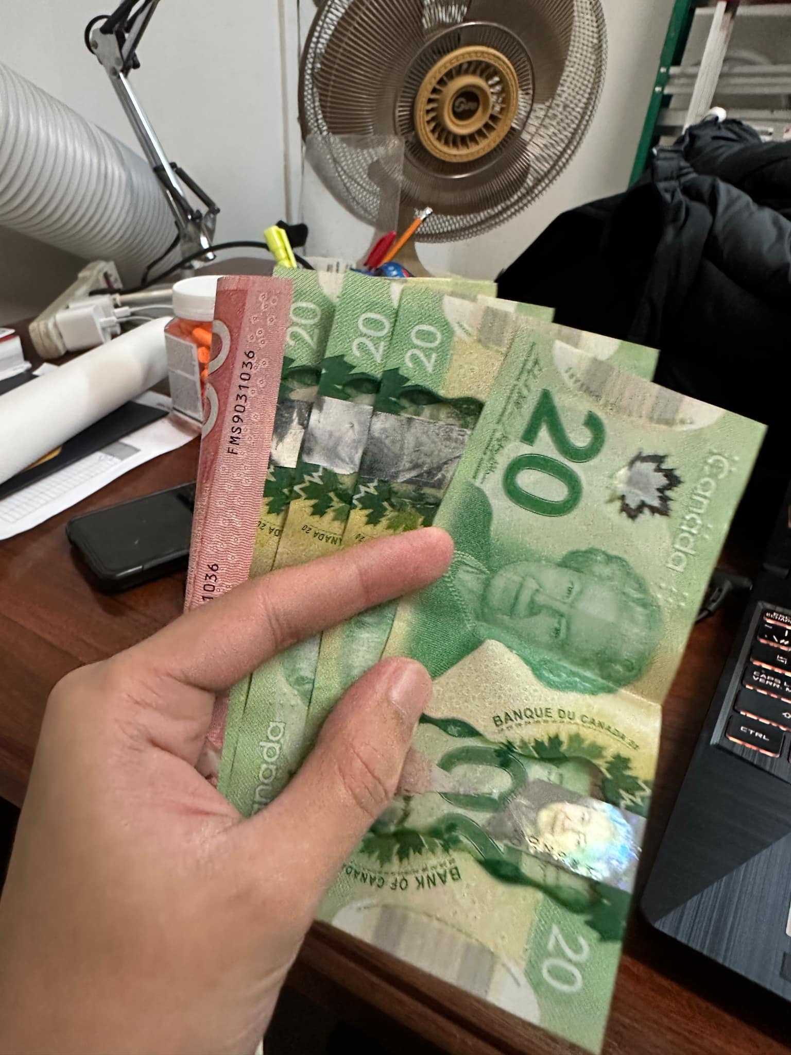

Activity 3: **Committing to Your Goals -** Author G. K. Chesterton's words, "There is one thing which gives radiance to everything. It is the idea of something around the corner."

I've started studying French and am working on it daily. I've wanted to do it for a while since I know it will lead to new chances for me, whether they be in travel, employment, or connecting with others.

I dedicate thirty minutes a day to studying. I watch videos, use applications, and even try saying simple words aloud. It looked overwhelming at first, especially with the complex grammar and pronunciation standards, but I've come to understand that consistency is important. Learning new words or phrases gives me an image of progress and keeps me going.

Learning French is about pushing myself and showing my ability to follow through on a goal, not simply about becoming fluent in the language. This daily routine has become an important part of my life, reminding me that if I put in the time and effort, I can achieve anything.

In The How of Happiness, Sonja Lyubomirsky says, “**Goals are those that you pursue because they are inherently satisfying and meaningful to you, which allow you to grow as a person, to develop emotional maturity”** (Lyubomirsky, 2008d, p. 208). This perfectly matches my goal of learning French every day.For me, learning French is about pushing oneself and pursuing a goal that feels meaningful, not just about taking up a new language. I'm reminded of why this objective is important to me every day when I learn new words and expressions. It's about creating new connections, expanding one's network, and growing personally.

Lyubomirsky's concept makes sense since pursuing a worthwhile objective gives one a feeling of direction. Even though it can be challenging at times, I stay driven by the little successes, such as correctly pronouncing a challenging word or comprehending a basic sentence. According to the book, the process of accomplishing a goal can be just as fulfilling as the final destination.

My experience and the phrase are similar in that they both highlight the fulfillment that results from never giving up on a significant goal. I feel a sense of accomplishment and joy in my development as I learn patience, discipline, and the importance of commitment via learning French. Fluency isn't the only goal; I also want to enjoy the process and know that I'm improving daily.



Week 4:

Activity 1: **Practicing Acts of Kindness -** "True happiness consists in making others happy,"

I made the decision to take care of myself and my neighborhood last weekend. I believed that putting flowers on the little area of land next to my house would make it look more lively and less gloomy. I visited a nearby nursery and selected a variety of colorful marigolds, petunias, and daisies—flowers that would create the surroundings with brightness and cheerfulness.  
  
I watered throughout the flowers every afternoon. Some of my neighbors smiled and even stopped to talk as I worked. Their encouraging remarks and the goal of planting was to create a small area of beauty that everyone could appreciate, not just the flowers. It now brings a smile to my face each time I pass that flower area. This act as a reminder that even tiny acts of kindness, like making a location more beautiful, can make people around you happy in addition to yourself. The street feels more friendly because to the vibrant colors and energy the flowers brings, and I'm happy I took the time to do something worthwhile for my neighborhood. In the process, there are also happy times. The experience is enjoyable when I meet new people, explore new areas of the city, and receive positive reviews from customers. At the same time, it's teaching me valuable lessons about patience, hard work, and the importance of establishing and maintaining goals.  
  
  
In The, How of Happiness, Sonja Lyubomirsky states, "We must all pitch in to improve the

Environment” (Lyubomirsky, 2008d, p. 129). This perfectly matches my experience of planting flowers beside my home to beautify the space for myself and my neighbors.   
What started off as a straightforward concept to add some color to a gloomy corner transformed into something more significant. A few neighbors stopped by to say how nice the marigolds and petunias looked as I planted them. Some even talked about how they were motivated to reorganize their personal areas or establish their gardens. Seeing how a tiny act of kindness might make amazing.  
  
This supports the idea put forth by Lyubomirsky that even simple acts of compassion have the power to have a big impact. In addition to making the street more beautiful, my flowers inspired people to take action and fostered a sense of community and shared concern.   
The quotation and my own experience both demonstrate how kindness, even in its simplest forms, may motivate people and bring happiness. It serves as a reminder that one considerate act at a time.

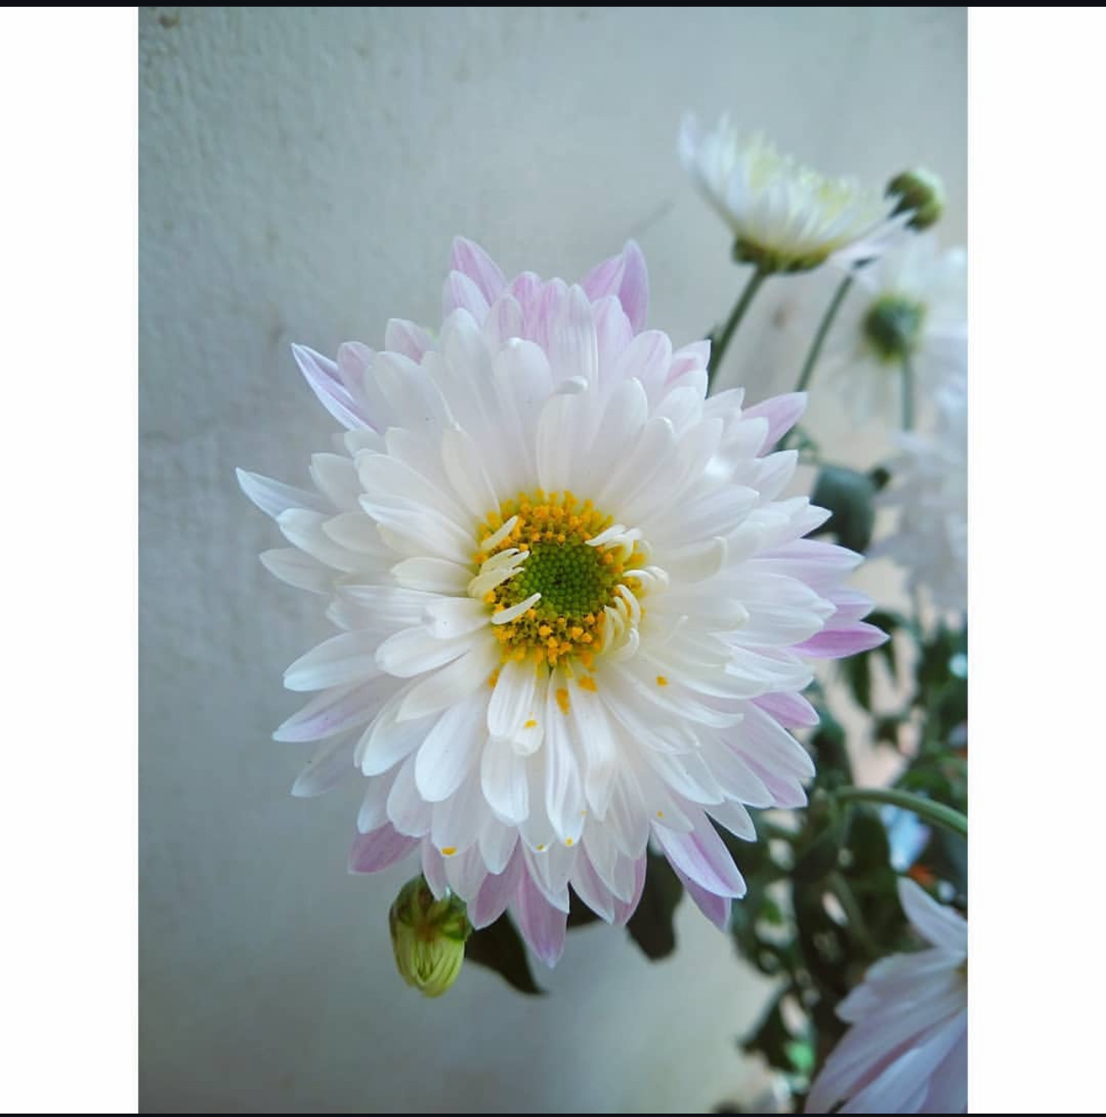

Activity 2:  **Practicing Religion and Spirituality**

Forgiveness is a key component of finding serenity and letting go of negativity. Although it's not always simple, it aids in clearing the mind of sorrow and anger. When I decide to forgive someone, I'm doing it for me as much as for them. It's a method to get better and go on without being burdened by past hurts.  
  
Saying that it was alright or forgetting what happened are not examples of forgiveness. It's about realizing that clinging to my pain would just make it worse over time. I may release myself from the situation's or person's emotional control when I forgive. It helps me find inner calm and clarity.

Forgiveness, in my opinion, is also about development. It instills compassion, empathy, and patience. I remind myself when I forgive that everyone makes errors and that I may eventually need forgiveness from others. Forgiveness improves relationships and contributes to a happier, peaceful life.

The How of Happiness, Sonja Lyubomirsky discusses the transformative power of spiritual practices, stating: **“A slew of studies has shown that highly religious and spiritual individuals see themselves as more forgiving and value forgiveness more than do their peers.”** (Lyubomirsky, 2008d, p. 238). This closely aligns with the act of practicing forgiveness.

Because it helps us to let go of anger and resentment and makes room for inner calm, forgiveness has a profound spiritual connection. For me, choosing to forgive someone is about releasing myself from the negativity that can drag me down, not simply about the person who harmed me. According to Lyubomirsky, spiritual activities foster empathy and comprehension, two qualities that are necessary for forgiveness. By extending forgiveness, I am demonstrating empathy and admitting that I am not the only one who makes errors.

My experience and the phrase are similar in that they both stress how important forgiveness is to one's own development and recovery. Forgiveness enables us to embrace peace and let go of grudges, which is something that spirituality frequently encourages us to accomplish. It's an effective strategy for moving forward and building a happier, more satisfying existence for ourselves and others around us.



Activity 3: **Committing to Your Goals -** Consider as an exercise the most important and meaningful goal that you are currently pursuing, whether big or small.

I've made the decision to start reading books on a regular basis, and this year, I want to finish ten volumes. I've been intending to do it for a while because I know it will help me focus better, learn somethings.  
  
I've already chosen a few books to begin with that address subjects that interest me, such as technology, storytelling, and self-improvement. Whether it's before bed or during a peaceful time of day, I intend to set aside thirty minutes each day to read. Although it may seem like a little step, I am positive that consistency will enable me achieve my goal.

This is about making a habit that will help me improve as a person, not merely finishing a lot of books. I'm eager to see how these books can expand my mind and inspire new ideas. I have a clear purpose and a strategy to push myself all year long when I set this objective.

In The How of Happiness, Sonja Lyubomirsky says, “**People whose primary life goals are intrinsically rewarding obtain more satisfaction and pleasure.”** (Lyubomirsky, 2008d, p. 208). This aligns perfectly with my decision to start reading books and set a goal of finishing 10 books this year.

Reading books is more than simply a way for me to spend my time; it's a means of learning, developing, and discovering subjects that are important to me. Each book I finish will inspire new ideas and help me develop myself. Like Lyubomirsky says, when you set a goal that matters to you, it keeps you motivated and brings happiness along the way.

By establishing this goal, I have something daily to dedicate myself toward. Reading for just thirty minutes a day will help me accomplish my goal and create a positive habit. The quote and my own experience both demonstrate that pursuing goals we are passionate about is about more than simply the final product; it's also about taking advantage of the process and being pleased with the progress made.



**Citations:**

Lyubomirsky, S. (2008d). The how of happiness : a new approach to getting the life you want. In *Penguin Books*. http://ci.nii.ac.jp/ncid/BA90160201